实验七 图像处理综合实验

一、实验目的
1. 能够分析实验项目的任务要求，将复杂图像处理系统分解为简单的算法模块。
2. 能够利用已学的图像增强、分割、形态学运算、区域特征提取、彩色图像处理等方法实现1中各算法模块。
- 能够将各模块综合在一起，进行调试，分析结果，得出结论
- 能够根据分析，优化设计，提升性能
- 通过分析与综合，培养学生运用所学知识与技能解决实际复杂问题的能力
二、实验内容及要求

（2）药片分类与计数：根据颜色、形状、大小等特征区分药片，并统计每种有几个
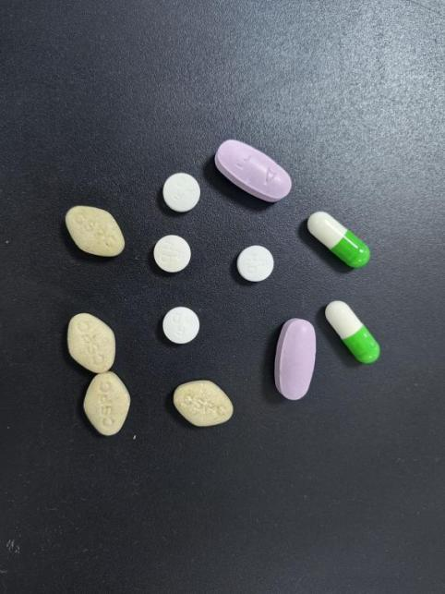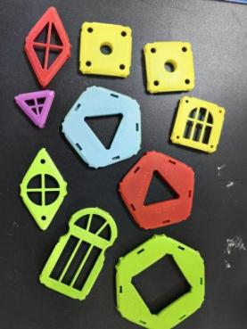
方法一
% 读取图像
A = imread("C:\Users\27492\Desktop\IMG\素材\图片1.png");
imshow(A);
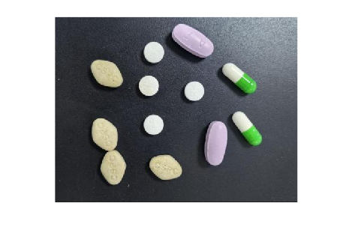
使用matlab中自带的app——彩色分割器，将菱形黄色和椭圆紫色的药片识别出来
实验选择用ycbcr进行
%分割紫色药片
function [BW,maskedRGBImage] = createMask(RGB)
%createMask Threshold RGB image using auto-generated code from colorThresholder app.
% [BW,MASKEDRGBIMAGE] = createMask(RGB) thresholds image RGB using
% auto-generated code from the colorThresholder app. The colorspace and
% range for each channel of the colorspace were set within the app. The
% segmentation mask is returned in BW, and a composite of the mask and
% original RGB images is returned in maskedRGBImage.

% Auto-generated by colorThresholder app on 07-May-2025
%------------------------------------------------------

% Convert RGB image to chosen color space
I = rgb2ycbcr(RGB);

% Define thresholds for channel 1 based on histogram settings
channel1Min = 151.000;
channel1Max = 255.000;

% Define thresholds for channel 2 based on histogram settings
channel2Min = 133.000;
channel2Max = 141.000;

% Define thresholds for channel 3 based on histogram settings
channel3Min = 130.000;
channel3Max = 255.000;

% Create mask based on chosen histogram thresholds
sliderBW = (I(:,:,1) >= channel1Min ) & (I(:,:,1) <= channel1Max) & ...
(I(:,:,2) >= channel2Min ) & (I(:,:,2) <= channel2Max) & ...
(I(:,:,3) >= channel3Min ) & (I(:,:,3) <= channel3Max);
BW = sliderBW;

% Initialize output masked image based on input image.
maskedRGBImage = RGB;

% Set background pixels where BW is false to zero.
maskedRGBImage(repmat(~BW,[1 1 3])) = 0;

end
E=createMask(A);
imshow(E);
用APP——图像区域分析器，处理多余的白色区域
function [BW_out,properties] = filterRegions(BW_in)
%filterRegions Filter BW image using auto-generated code from imageRegionAnalyzer app.

% Auto-generated by imageRegionAnalyzer app on 07-May-2025
%---------------------------------------------------------

BW_out = BW_in;

% Filter image based on image properties.
BW_out = bwpropfilt(BW_out,'Area',[2700, 2842]);

% Get properties.
properties = regionprops(BW_out, {'Area', 'Circularity', 'Eccentricity', 'EquivDiameter', 'EulerNumber', 'MajorAxisLength', 'MinorAxisLength', 'Orientation', 'Perimeter'});

end
E1=filterRegions(E);title("分割出紫色药片的二值图像")
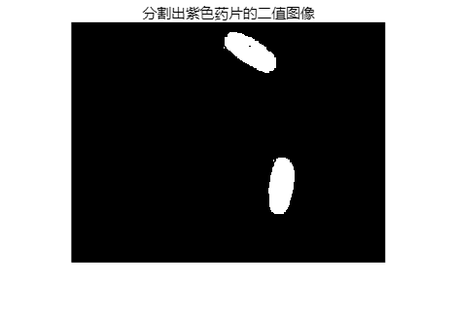
用bwlabel计数
[L,num]=bwlabel(E1);
%输出对象数量
disp(['紫色药片的数目',num2str(num)]);
紫色药片的数目2
同理，用相同的方法处理黄色的方形药片
%分割黄色方形药片采用hsv
function [BW,maskedRGBImage] = createMask_1(RGB)
%createMask Threshold RGB image using auto-generated code from colorThresholder app.
% [BW,MASKEDRGBIMAGE] = createMask(RGB) thresholds image RGB using
% auto-generated code from the colorThresholder app. The colorspace and
% range for each channel of the colorspace were set within the app. The
% segmentation mask is returned in BW, and a composite of the mask and
% original RGB images is returned in maskedRGBImage.

% Auto-generated by colorThresholder app on 07-May-2025
%------------------------------------------------------

% Convert RGB image to chosen color space
I = rgb2hsv(RGB);

% Define thresholds for channel 1 based on histogram settings
channel1Min = 0.078;
channel1Max = 0.187;

% Define thresholds for channel 2 based on histogram settings
channel2Min = 0.108;
channel2Max = 0.394;

% Define thresholds for channel 3 based on histogram settings
channel3Min = 0.648;
channel3Max = 1.000;

% Create mask based on chosen histogram thresholds
sliderBW = (I(:,:,1) >= channel1Min ) & (I(:,:,1) <= channel1Max) & ...
(I(:,:,2) >= channel2Min ) & (I(:,:,2) <= channel2Max) & ...
(I(:,:,3) >= channel3Min ) & (I(:,:,3) <= channel3Max);
BW = sliderBW;

% Initialize output masked image based on input image.
maskedRGBImage = RGB;

% Set background pixels where BW is false to zero.
maskedRGBImage(repmat(~BW,[1 1 3])) = 0;

end
Y=createMask_1(A);
imshow(Y);title("未经处理的黄色药片")
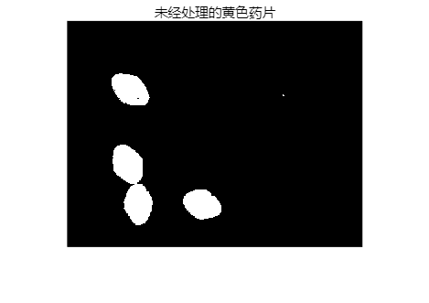
发现药片之间有粘连的情况，使用开运算
r1=10%调控结构元素se的半径
r1 = 10
% (通过调节此数值得出可以完整分割出圆形药片的方法
se1=strel('disk',r1)%生成圆形结构元素
se1 =
strel 是具有以下属性的 disk 形结构元素: Neighborhood: [19×19 logical] Dimensionality: 2
Y2=imopen(Y,se1);
imshow(Y2);title("用开运算处理后黄色药片的二值图像")
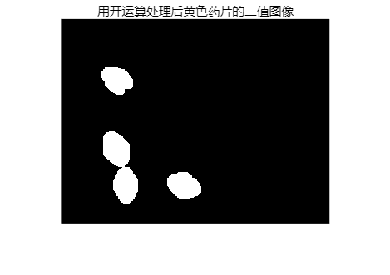
用bwlabel计数
[L,num1]=bwlabel(Y2);
%输出对象数量
disp(['黄色方形药片的数目',num2str(num1)]);
黄色方形药片的数目4
运用app——彩色分割器，分割出胶囊和圆形白色药片
function [BW,maskedRGBImage] = createMask_2(RGB)
%createMask Threshold RGB image using auto-generated code from colorThresholder app.
% [BW,MASKEDRGBIMAGE] = createMask(RGB) thresholds image RGB using
% auto-generated code from the colorThresholder app. The colorspace and
% range for each channel of the colorspace were set within the app. The
% segmentation mask is returned in BW, and a composite of the mask and
% original RGB images is returned in maskedRGBImage.

% Auto-generated by colorThresholder app on 08-May-2025
%------------------------------------------------------

% Convert RGB image to chosen color space
I = rgb2hsv(RGB);

% Define thresholds for channel 1 based on histogram settings
channel1Min = 0.428;
channel1Max = 0.173;

% Define thresholds for channel 2 based on histogram settings
channel2Min = 0.076;
channel2Max = 0.350;

% Define thresholds for channel 3 based on histogram settings
channel3Min = 0.045;
channel3Max = 1.000;

% Create mask based on chosen histogram thresholds
sliderBW = ( (I(:,:,1) >= channel1Min) | (I(:,:,1) <= channel1Max) ) & ...
(I(:,:,2) >= channel2Min ) & (I(:,:,2) <= channel2Max) & ...
(I(:,:,3) >= channel3Min ) & (I(:,:,3) <= channel3Max);
BW = sliderBW;

% Invert mask
BW = ~BW;

% Initialize output masked image based on input image.
maskedRGBImage = RGB;

% Set background pixels where BW is false to zero.
maskedRGBImage(repmat(~BW,[1 1 3])) = 0;

end
E3=createMask_2(A);
imshow(E3);title("彩色分割器，分割出胶囊和圆形白色药片")
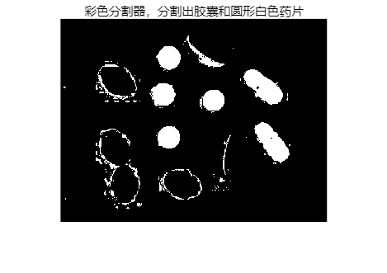
使用开运算和闭运算去除多余部分
(即，先使用开运算腐蚀多余部分，再用闭运算还原）
r2=11%调控结构元素se的半径
r2 = 11
% (通过调节此数值得出可以完整分割出圆形药片的方法
se2=strel('disk',r2)%生成圆形结构元素
se2 =
strel 是具有以下属性的 disk 形结构元素: Neighborhood: [21×21 logical] Dimensionality: 2
E4=imopen(E3,se2);
E5=imclose(E4,se2);
imshow(E5);title("用开运算和闭运算去除多余部分")
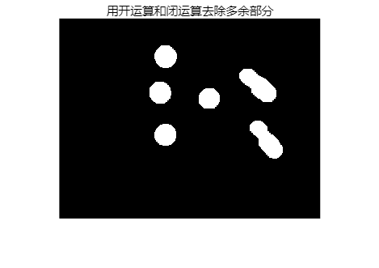
用APP——图像区域分析器，将胶囊提取出来
（胶囊与小药片面积存在明显不同，故使用面积筛选出）
%筛选出胶囊
function [BW_out,properties] = filterRegions_1(BW_in)
%filterRegions Filter BW image using auto-generated code from imageRegionAnalyzer app.

% Auto-generated by imageRegionAnalyzer app on 08-May-2025
%---------------------------------------------------------

BW_out = BW_in;

% Filter image based on image properties.
BW_out = bwpropfilt(BW_out,'Area',[2000, 2374]);

% Get properties.
properties = regionprops(BW_out, {'Area', 'Circularity', 'Eccentricity', 'EquivDiameter', 'EulerNumber', 'MajorAxisLength', 'MinorAxisLength', 'Orientation', 'Perimeter'});
end
E6= filterRegions_1(E5);
imshow(E6);
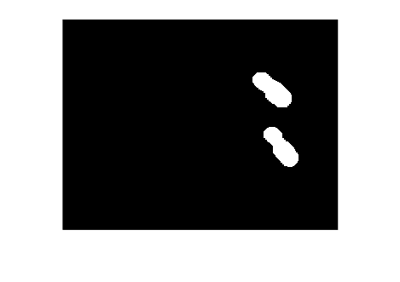
用bwlabel计数
[L,num2]=bwlabel(E6);
%输出对象数量
disp(['胶囊的数目为',num2str(num2)]);
胶囊的数目为2
用相同的方法计算出白色小药片的数目
%筛选出白色小药片
function [BW_out,properties] = filterRegions_2(BW_in)
%filterRegions Filter BW image using auto-generated code from imageRegionAnalyzer app.

% Auto-generated by imageRegionAnalyzer app on 08-May-2025
%---------------------------------------------------------

BW_out = BW_in;

% Filter image based on image properties.
BW_out = bwpropfilt(BW_out,'Area',[1205, 2000]);

% Get properties.
properties = regionprops(BW_out, {'Area', 'Circularity', 'Eccentricity', 'EquivDiameter', 'EulerNumber', 'MajorAxisLength', 'MinorAxisLength', 'Orientation', 'Perimeter'});
end
E7 = filterRegions_2(E5);
imshow(E7);
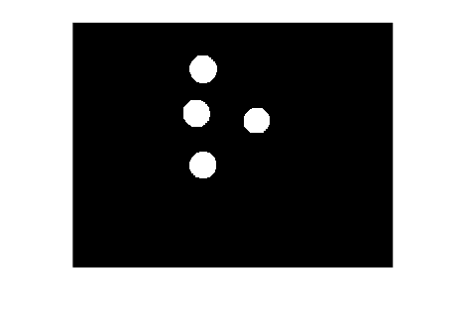
%计数
[L,num3]=bwlabel(E7);
%输出对象数量
disp(['白色小药片的数目为',num2str(num3)]);
白色小药片的数目为4
方法二
% 读取图像
I = imread("C:\Users\27492\Desktop\IMG\演示作业\药片1.jpg");
%转化为灰度图像
I1 = rgb2gray(I);
imshow(I1);
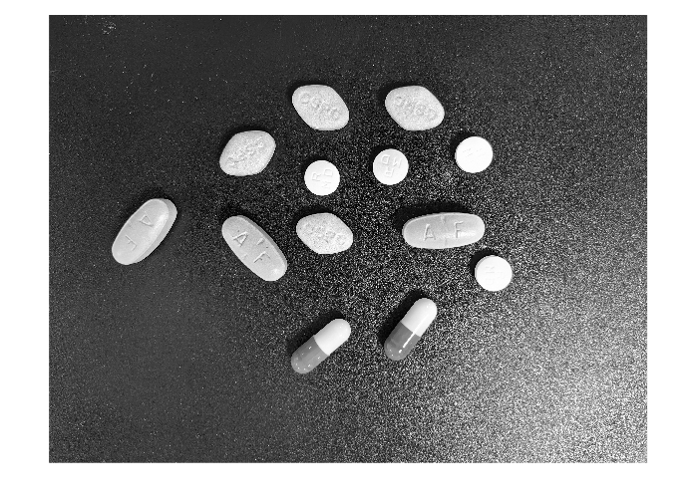
D5=28
D5 = 28
se14 = strel('disk',D5)
se14 =
strel 是具有以下属性的 disk 形结构元素: Neighborhood: [55×55 logical] Dimensionality: 2
BW = imopen(I1,se14);
%将灰度图像转化为二值图像
C3=imbinarize(BW);
imshow(C3);
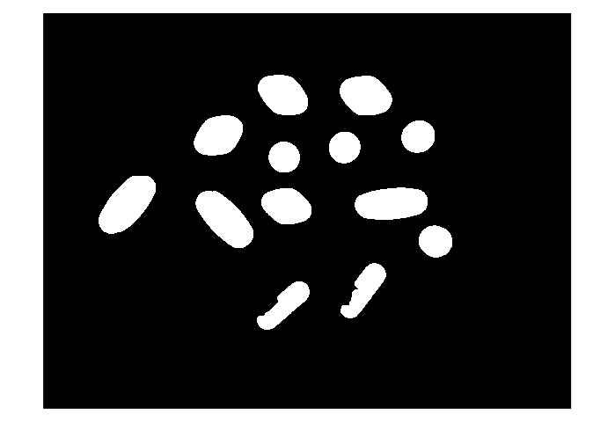
紫色药片
%紫色药片
function [BW_out,properties] = filterRegions_1(BW_in)
%filterRegions Filter BW image using auto-generated code from imageRegionAnalyzer app.

% Auto-generated by imageRegionAnalyzer app on 08-May-2025
%---------------------------------------------------------

BW_out = BW_in;

% Filter image based on image properties.
BW_out = bwpropfilt(BW_out,'Area',[100000, 118751]);

% Get properties.
properties = regionprops(BW_out, {'Area', 'Circularity', 'Eccentricity', 'EquivDiameter', 'EulerNumber', 'MajorAxisLength', 'MinorAxisLength', 'Orientation', 'Perimeter'});
end
Q1 = filterRegions_1(C3)
Q1 = 3000×4000 logical 数组
0 0 0 0 0 0 0 0 0 0 0 0 0 0 0 0 0 0 ⋯
0 0 0 0 0 0 0 0 0 0 0 0 0 0 0 0 0 0
0 0 0 0 0 0 0 0 0 0 0 0 0 0 0 0 0 0
0 0 0 0 0 0 0 0 0 0 0 0 0 0 0 0 0 0
0 0 0 0 0 0 0 0 0 0 0 0 0 0 0 0 0 0
0 0 0 0 0 0 0 0 0 0 0 0 0 0 0 0 0 0
0 0 0 0 0 0 0 0 0 0 0 0 0 0 0 0 0 0
0 0 0 0 0 0 0 0 0 0 0 0 0 0 0 0 0 0
0 0 0 0 0 0 0 0 0 0 0 0 0 0 0 0 0 0
0 0 0 0 0 0 0 0 0 0 0 0 0 0 0 0 0 0
⋮
[L,num]=bwlabel(Q1);
%输出对象数量
disp(['紫色药片的数目',num2str(num)]);
紫色药片的数目3
黄色菱形药片
function [BW_out,properties] = filterRegions_2(BW_in)
%filterRegions Filter BW image using auto-generated code from imageRegionAnalyzer app.

% Auto-generated by imageRegionAnalyzer app on 08-May-2025
%---------------------------------------------------------

BW_out = BW_in;

% Filter image based on image properties.
BW_out = bwpropfilt(BW_out,'Area',[79000, 100000]);

% Get properties.
properties = regionprops(BW_out, {'Area', 'Circularity', 'Eccentricity', 'EquivDiameter', 'EulerNumber', 'MajorAxisLength', 'MinorAxisLength', 'Orientation', 'Perimeter'});
end
Q2= filterRegions_2(C3);
[L,num2]=bwlabel(Q2);
%输出对象数量
disp(['黄色菱形药片的数目',num2str(num2)]);
黄色菱形药片的数目4

白色圆形小药片
function [BW_out,properties] = filterRegions_3(BW_in)
%filterRegions Filter BW image using auto-generated code from imageRegionAnalyzer app.

% Auto-generated by imageRegionAnalyzer app on 08-May-2025
%---------------------------------------------------------

BW_out = BW_in;

% Filter image based on image properties.
BW_out = bwpropfilt(BW_out,'Area',[42000, 50000]);

% Get properties.
properties = regionprops(BW_out, {'Area', 'Circularity', 'Eccentricity', 'EquivDiameter', 'EulerNumber', 'MajorAxisLength', 'MinorAxisLength', 'Orientation', 'Perimeter'});
end
Q3= filterRegions_3(C3);
[L,num3]=bwlabel(Q3);
%输出对象数量
disp(['白色圆形小药片的数目',num2str(num3)]);
白色圆形小药片的数目4
胶囊数目
function [BW_out,properties] = filterRegions_4(BW_in)
%filterRegions Filter BW image using auto-generated code from imageRegionAnalyzer app.

% Auto-generated by imageRegionAnalyzer app on 08-May-2025
%---------------------------------------------------------

BW_out = BW_in;

% Filter image based on image properties.
BW_out = bwpropfilt(BW_out,'Area',[50000, 73000]);

% Get properties.
properties = regionprops(BW_out, {'Area', 'Circularity', 'Eccentricity', 'EquivDiameter', 'EulerNumber', 'MajorAxisLength', 'MinorAxisLength', 'Orientation', 'Perimeter'});
end
Q4= filterRegions_4(C3);
imshow(Q4)
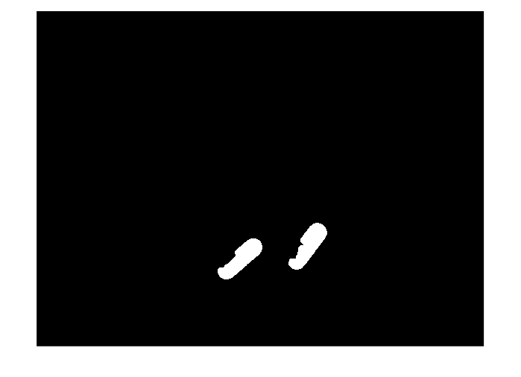
[L,num4]=bwlabel(Q4);
%输出对象数量
disp(['胶囊的数目',num2str(num4)]);
胶囊的数目2

方法三
% 读取图像
I = imread("C:\Users\27492\Desktop\IMG\演示作业\药片1.jpg");
imshow(I);title("原图")
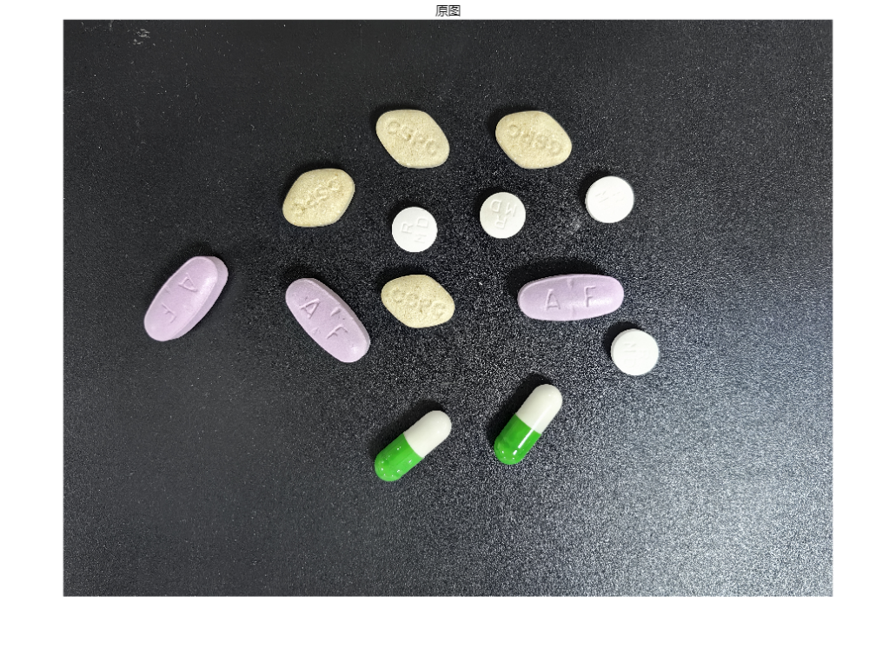
%将图片转化为灰度图
I1 = rgb2gray(I);
imshow(I1);
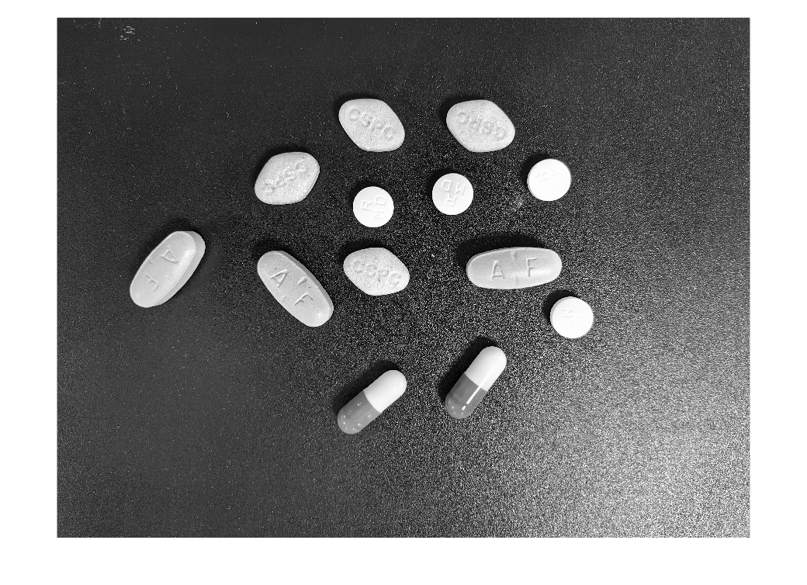
%用自适应阈值分割处理图像（处理图片光照不均匀）
T= adaptthresh(I1,0.4,'ForegroundPolarity', 'dark');
%imshow(T);
BW=imbinarize(I1,T);%将图像二值化
imshow(BW);
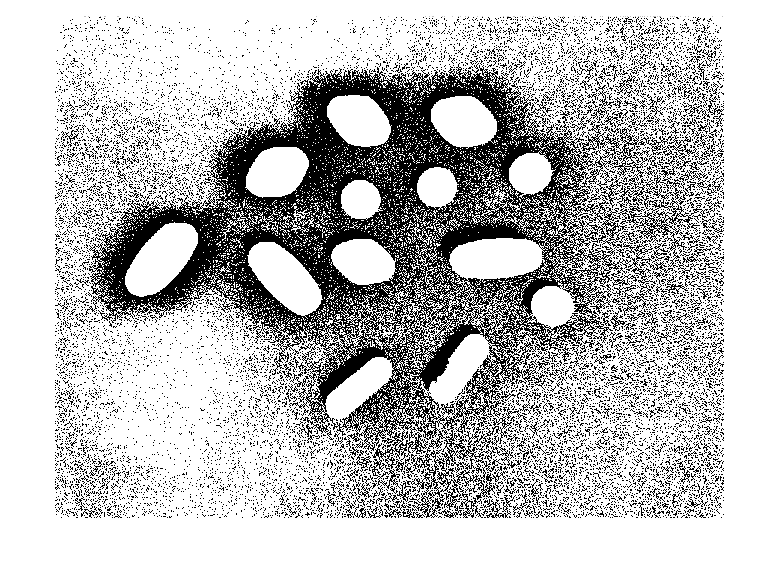
r1=68%调控结构元素se的半径
r1 = 68
% (通过调节此数值得出可以完整分割出圆形药片的方法
se1=strel('disk',r1)%生成圆形结构元素
se1 =
strel 是具有以下属性的 disk 形结构元素: Neighborhood: [135×135 logical] Dimensionality: 2
C3=imopen(BW,se1)%开运算将背景中的小白点去除
C3 = 3000×4000 logical 数组
0 0 0 0 0 0 0 0 0 0 0 0 0 0 0 0 0 0 ⋯
0 0 0 0 0 0 0 0 0 0 0 0 0 0 0 0 0 0
0 0 0 0 0 0 0 0 0 0 0 0 0 0 0 0 0 0
0 0 0 0 0 0 0 0 0 0 0 0 0 0 0 0 0 0
0 0 0 0 0 0 0 0 0 0 0 0 0 0 0 0 0 0
0 0 0 0 0 0 0 0 0 0 0 0 0 0 0 0 0 0
0 0 0 0 0 0 0 0 0 0 0 0 0 0 0 0 0 0
0 0 0 0 0 0 0 0 0 0 0 0 0 0 0 0 0 0
0 0 0 0 0 0 0 0 0 0 0 0 0 0 0 0 0 0
0 0 0 0 0 0 0 0 0 0 0 0 0 0 0 0 0 0
⋮
imshow(C3)
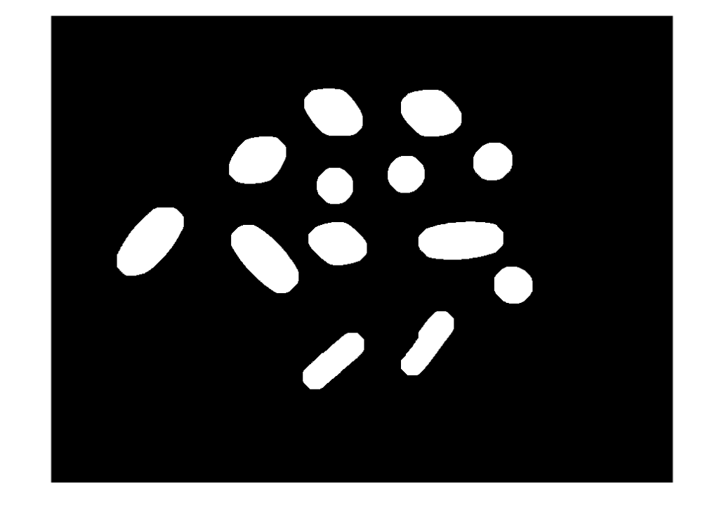
%E5=I.*uint8(C3)%相乘就相当于把C3当做遮罩层，把药片抠出来
%imshow(E5)
用APP图像区域分析器
分离出不同面积的药片
紫色药片
%紫色药片
function [BW_out,properties] = filterRegions_1(BW_in)
%filterRegions Filter BW image using auto-generated code from imageRegionAnalyzer app.

% Auto-generated by imageRegionAnalyzer app on 08-May-2025
%---------------------------------------------------------

BW_out = BW_in;

% Filter image based on image properties.
BW_out = bwpropfilt(BW_out,'Area',[100000, 118751]);

% Get properties.
properties = regionprops(BW_out, {'Area', 'Circularity', 'Eccentricity', 'EquivDiameter', 'EulerNumber', 'MajorAxisLength', 'MinorAxisLength', 'Orientation', 'Perimeter'});
end
Q1 = filterRegions_1(C3)
Q1 = 3000×4000 logical 数组
0 0 0 0 0 0 0 0 0 0 0 0 0 0 0 0 0 0 ⋯
0 0 0 0 0 0 0 0 0 0 0 0 0 0 0 0 0 0
0 0 0 0 0 0 0 0 0 0 0 0 0 0 0 0 0 0
0 0 0 0 0 0 0 0 0 0 0 0 0 0 0 0 0 0
0 0 0 0 0 0 0 0 0 0 0 0 0 0 0 0 0 0
0 0 0 0 0 0 0 0 0 0 0 0 0 0 0 0 0 0
0 0 0 0 0 0 0 0 0 0 0 0 0 0 0 0 0 0
0 0 0 0 0 0 0 0 0 0 0 0 0 0 0 0 0 0
0 0 0 0 0 0 0 0 0 0 0 0 0 0 0 0 0 0
0 0 0 0 0 0 0 0 0 0 0 0 0 0 0 0 0 0
⋮
[L,num]=bwlabel(Q1);
%输出对象数量
disp(['紫色药片的数目',num2str(num)]);
紫色药片的数目3
黄色菱形药片
function [BW_out,properties] = filterRegions_2(BW_in)
%filterRegions Filter BW image using auto-generated code from imageRegionAnalyzer app.

% Auto-generated by imageRegionAnalyzer app on 08-May-2025
%---------------------------------------------------------

BW_out = BW_in;

% Filter image based on image properties.
BW_out = bwpropfilt(BW_out,'Area',[79000, 100000]);

% Get properties.
properties = regionprops(BW_out, {'Area', 'Circularity', 'Eccentricity', 'EquivDiameter', 'EulerNumber', 'MajorAxisLength', 'MinorAxisLength', 'Orientation', 'Perimeter'});
end
Q2= filterRegions_2(C3);
[L,num2]=bwlabel(Q2);
%输出对象数量
disp(['黄色菱形药片的数目',num2str(num2)]);
黄色菱形药片的数目4

白色圆形小药片
function [BW_out,properties] = filterRegions_3(BW_in)
%filterRegions Filter BW image using auto-generated code from imageRegionAnalyzer app.

% Auto-generated by imageRegionAnalyzer app on 08-May-2025
%---------------------------------------------------------

BW_out = BW_in;

% Filter image based on image properties.
BW_out = bwpropfilt(BW_out,'Area',[43627, 50000]);

% Get properties.
properties = regionprops(BW_out, {'Area', 'Circularity', 'Eccentricity', 'EquivDiameter', 'EulerNumber', 'MajorAxisLength', 'MinorAxisLength', 'Orientation', 'Perimeter'});
end
Q3= filterRegions_3(C3);
[L,num3]=bwlabel(Q3);
%输出对象数量
disp(['白色圆形小药片的数目',num2str(num3)]);
白色圆形小药片的数目4
胶囊数目
function [BW_out,properties] = filterRegions_4(BW_in)
%filterRegions Filter BW image using auto-generated code from imageRegionAnalyzer app.

% Auto-generated by imageRegionAnalyzer app on 08-May-2025
%---------------------------------------------------------

BW_out = BW_in;

% Filter image based on image properties.
BW_out = bwpropfilt(BW_out,'Area',[50000, 73000]);

% Get properties.
properties = regionprops(BW_out, {'Area', 'Circularity', 'Eccentricity', 'EquivDiameter', 'EulerNumber', 'MajorAxisLength', 'MinorAxisLength', 'Orientation', 'Perimeter'});
end
Q4= filterRegions_4(C3);
imshow(Q4)
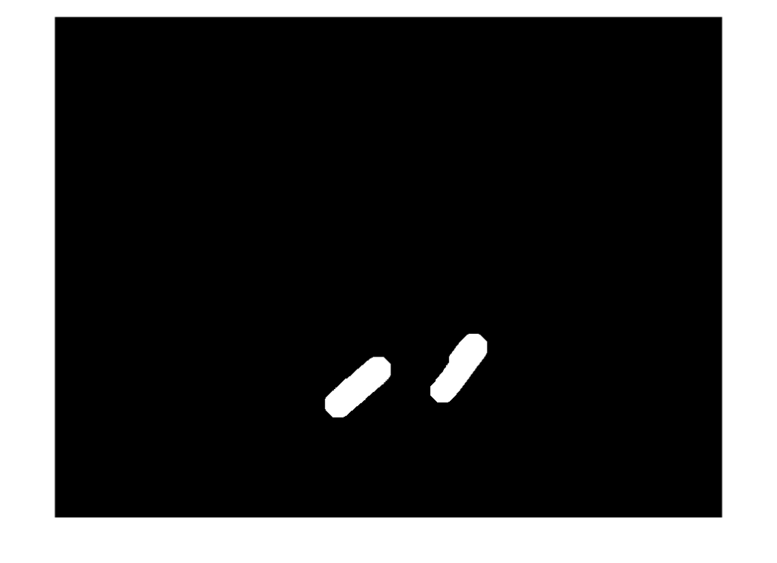
[L,num4]=bwlabel(Q4);
%输出对象数量
disp(['胶囊的数目',num2str(num4)]);
胶囊的数目2

2.根据设计方案将问题分解为各模块：增强？分割（灰度值？颜色？等）？特征提取？模式分类？
3.模块化实现每一部分内容
4.调试与测试实验，记录结果
三、实验方案及算法原理
在上文均有备注
四、实验步骤（根据任务及方案，设计实验步骤）
1.分析题目及要求，进行模块化方案设计
方案1
直接读取图像后将图像进行自适应阈值分割
后运用开运算腐蚀背景产生的雪花点
因为各个种类药片面积不同
所以用app图像区域分析器进行处理
对处理后的图片进行标记计数

方案2
根据药片颜色不同的特点，用APP颜色分割器将菱形黄色和椭圆紫色的药片识别出来
由于胶囊与白色小药片无法用APP单独提取，于是把它们一起提取出来，然后用使用开运算和闭运算去除多余部分
依据胶囊和小药片面积不同，采用APP图像区域分析器进行处理，最后对结果进行标记计数
2.各模块算法设计与实现，记录结果
3.各模块综合在一起，进行测试实验，记录不同情况下实验结果
（以上未填写的点在上文实验步骤中均有备注）

- 实验结果分析
灵活运用matlabe中自带的APP完成药片的分割
六、记录实验中出现的问题
实验中发现光照对后期处理影响较大，采用了自适应阈值分割先处理图像在进行后续操作
七、心得体会
此次实验将我前面所学的知识都运用到了，让我很有成就感，也温故而知新学到了很多新的知识

附录：
分类或识别可以使用神经网络进行模式识别的APP进行，首先需要提取特征，然后把特征送入网络进行训练。
